Deterding Pool Safety Guidelines
- Those who are not strong swimmers are encouraged to bring a lifejacket. The lifejacket must say it is US Coastguard certified. Only US Coastguard certified lifejackets are permitted. See flotation device policy for additional details.
- For those who are not strong swimmers but want to swim in the deep end/go off the diving board, a swim test can be administered. The test is an easy swim across our small pool from side to side (26 feet across). Those who are unable to pass will receive a wrist band and are not permitted in the deep end or on the diving board.
- Goggles that cover the nose cannot be worn. In case of an emergency, there must be access to the airway.
- We do not allow any floating equipment, float rings, or noodles.
- Patrons must walk on the pool deck. As people enter and exit the pool the deck becomes wet and slippery.
- Adults, please make sure to stay close to your non-swimmers. We want to prevent any accidents before they happen.
Pool Rules
- No One will enter the pool without a lifeguard on duty.
- Anyone under the age of 12 must be accompanied by a person 16 or older.
- Children must be supervised at all times.
- No hypoxic (breath holding) games.
- No running on deck. Walking only
- No diving except from diving board and designated diving areas
- No flips from the edge of the pool or the slide
- No swimming in diving board and slide areas
- No swinging or hanging on ropes.
- No eating in the pool
- No horseplay in or around the pool (ex. dunking, throwing people, sitting on shoulders etc.)
- Everyone must enter the pool facing the water (no backwards entry)
- No floatation objects allowed in the pool except Coast Guard approved life jackets.
- No snorkels and no masks that cover the nose.
- No denim cut off or frayed shorts, ripped/dirty clothing or oversized shirts allowed in the pool.
- Shower before entering the pool.
- No glass objects, smoking, alcohol or chewing gum allowed in the pool complex.
- No one with an infection, diarrhea, inflamed eyes, skin disease etc. will be allowed into the pool.
- No animals (except service animals) are allowed in the pool complex (including restrooms)
- No weapons, abusive behavior or foul language allowed in the pool complex.
- Lifeguards have the right to prohibit any other activities that they deem inappropriate or unsafe.
- One long whistle blast from the lifeguard signals that the pool needs to be cleared. Please exit the pool quickly and return to the grass area and listen for further instructions from the lifeguards.
Diving Board Rules
- Only one person at a time is allowed on the diving board.
- The next person in line must wait on the ground until the diver reaches the wall or enters the deep end under the ropes.
- After diving the patron may either exit the pool to the stairs at the right or enter the deep end under the ropes to the left.
- One bounce is allowed on the board.
- Divers must go straight off the end of the board facing forward (no jumping off the side of the board or back flips.)
- Running on the diving board is not permitted.
- No swimming to the bottom drain
- Rule violators will be banned from the diving board for the day or for the season.
Slide Rules
- One person at a time on the slide
- The person in line must wait on the ground until the slider reaches the water.
- Walk up the stairs.
- Slider must go down the slide on their bottom or back only (no backward, face first, or spinning while sliding)
- Non-swimmers can be accompanied by an adult 18+
- No lifejackets on the slide
Adult Swim (For Public Swim Only)
- Adult swim lasts 15 minutes and begins on the 45 for the first two hours of Public Swim. All swimmers under the age of 18 must exit the pool. Any adults with Children aged 3 and under may swim in the big pool.

Floatation Device Policy
Water noodles, floaties, life vest and any other floatation devices are NOT allowed in the pool unless the life vest is US Coast Guard Certified! If it is, it will have a seal on it that says it’s certified by the US Coast Guard. If a life vest is worn by a patron a parent must be present in the water and they must be with in arms reach of a parent or guardian at all times. If a child wearing a life vest would like to go down the slide they must remove the vest and be accompanied by an adult 18 years or older. Someone wearing a life vest must wear a yellow wrist band, may not go to the deep end, and must be accompanied by an adult at all times.
THE FOLLOWING ARE NOT PERMITTED:
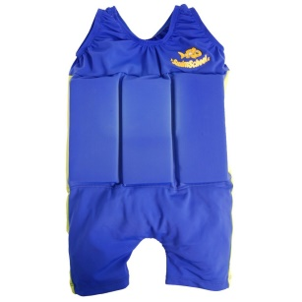
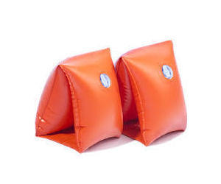
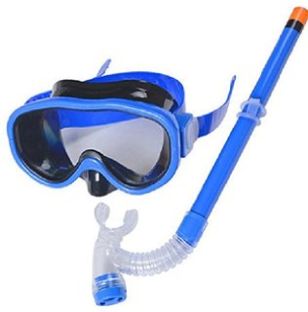


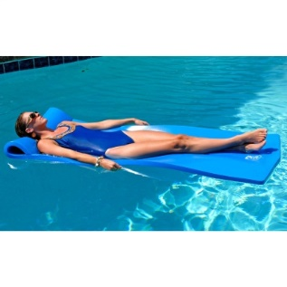
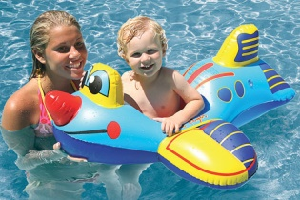
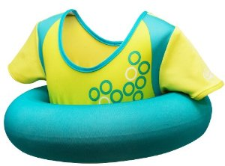

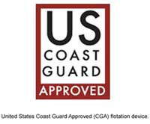
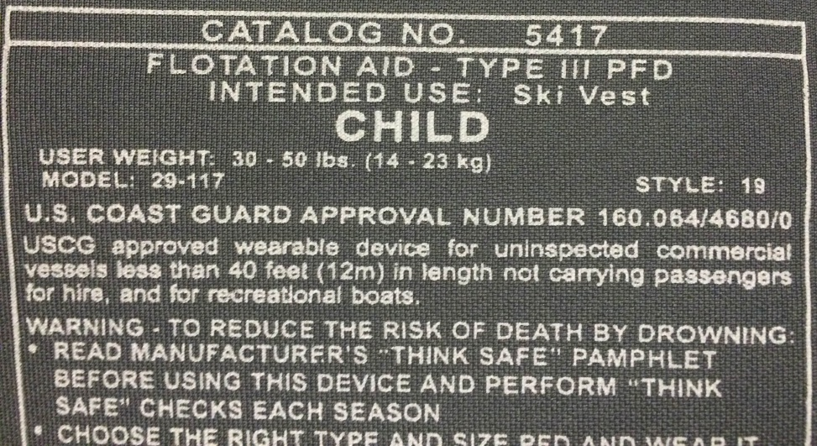
THE FOLLOWING ARE PERMITTED:

